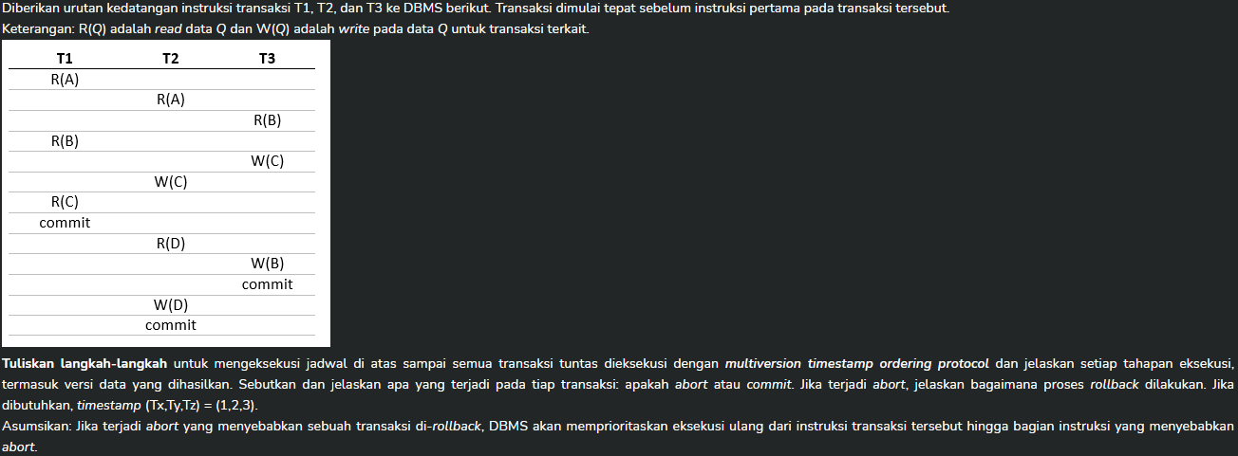

Harusnya A0<Qx, Rts, Wts> dengan Qx = nilai (di soal ini ga ada nilai jadi bebas), rts & wts = read write timestamp

|  |  |  |  |
| --- | --- | --- | --- |
| T1 | T2 | T3 |  |
| R(A) |  |  | Get A0, TS(A0) = (1,0) |
|  | R(A) |  | Get A0, TS(A0) = (2,0) |
|  |  | R(B) | Get B0, TS(B0) = (3,0) |
| R(B) |  |  | Get B0, TS(B0) = (3,0) |
|  |  | W(C) | Get C0, TS(C3) = (3,3) 🡨 harusnya TS(C1) karena versi 1 yang dihasilkan oleh transaksi 3 |
|  | W(C) |  | Get C0, TS(C2) = (2,2) |
| R(C) |  |  | Get C0, TS(C0) = (1,0) |
| Commit |  |  | Commit berhasil |
|  | R(D) |  | Get D0, TS(D0) = (2,0) |
|  |  | W(B) | Get B0, TS(B3) = (3,0) |
|  |  | Commit | Commit berhasil |
|  | W(D) |  | Get D0, TS(D2) = (2,2) |
|  | Commit |  | Commit berhasil |

|  |  |  |  |
| --- | --- | --- | --- |
| T1 | T2 | T3 | TS-counter = 0 |
| R(A) |  |  | TS(T1) = 0 karena read only, read A0 |
|  | R(A) |  | SL(A), read A0 |
|  |  | R(B) | SL(B), read B0 |
| R(B) |  |  | Read B0 |
|  |  | W(C) | XL(C), WTS C(inf) |
|  | W(C) |  | Wait for lock |
| R(C) |  |  | Read C0 |
| Commit |  |  | Commit berhasil, |
|  | R(D) |  | Wait for T2 |
|  |  | W(B) | XL(B), WTS B(inf) |
|  |  | Commit | Unlock(B), unlock(C), TS-counter = 1, C0🡪C1, B0 🡪 B1 |
|  | W(C) |  | XL(C), WTS C(inf) |
|  | R(D) |  | SL(D) |
|  | W(D) |  | XL(D), WTS D(inf) |
|  | Commit |  | Unlock(D), Unlock(C), unlock(A), TS-counter = 2, C1🡪C2, D0 🡪 D2 |

|  |  |  |  |
| --- | --- | --- | --- |
| T1 | T2 | T3 |  |
| R(A) |  |  | A0 = 10 |
|  | R(A) |  | A0 = 10 |
|  |  | R(B) | B0 = 20 |
| R(B) |  |  | B0 = 20 |
|  |  | C:= 50 |  |
|  |  | W(C) | C3 = 50 |
|  | C:=35 |  |  |
|  | W(C) |  | C2 = 35 |
| R(C) |  |  | C0 = 0 |
| Commit |  |  |  |
|  | R(D) |  | D0 = 30 |
|  |  | B:=B-0.1*C | B3 = 20 – 0.1*50 = 15 |
|  |  | W(B) | B3 = 15 |
|  |  | Commit | C3 = 50, B3 = 15 |
|  | D:=0.2*D+A |  | D2 = 0.2*30 + 10 |
|  | W(D) |  | D2 = 16 |
|  | Abort |  | Gagal commit karena C sudah diubah oleh T3 |
|  | R(A) |  | A0=10 |
|  | C:=35 |  |  |
|  | W(C) |  | C2=35 |
|  | R(D) |  | D0=30 |
|  | D:=….. |  | D=16y |
|  | W(D) |  | D2=10 |
|  | commit |  |  |